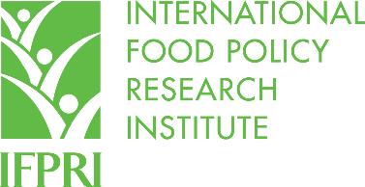

Proceedings of the First National Conference on Gender, Climate Change, and Nutrition Integration Initiative (GCAN) in Ethiopia
17 March 2026 @ Hilton Hotel
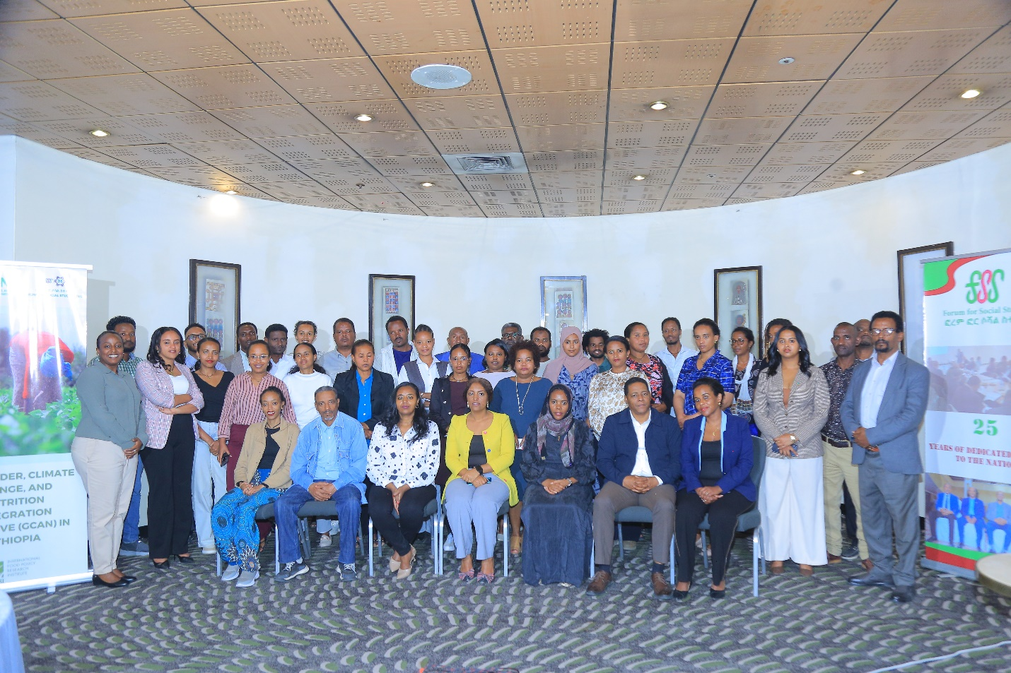


Contents

Introduction 3
Objectives of the Workshop 3
Morning Sessions: Conference Deliberations 5
Opening Speech by Dr. Yeraswork Admassie, FSS Executive Director 5
Keynote Speech: Mr. Abduljewad Mohammed Ministry of Irrigations and Lowlands; Chief Executive Officer 8
Presentation 1: Dr. Taddese Zerfu Overview of GCAN Project In Ethiopia 11
Panel Discussion 13
Reflections on the Panel discussion 17
Presentation 2: Dr. Selam Esayas Capacity Need Assessment on Selected Sectors Summary of Capacity Needs Assessment Findings (GCAN–Ethiopia) 19
Participant Reflections and Discussion 22
Afternoon sessions 25
Artistic performance 25
Paper presentation 1: Dr. Kalkidan Esayas (Environmentalist and Climate Change Advocate) From Vulnerability to Leadership: Empowering Women at the Nexus of Climate Change, Gender Equality, and Nutrition Security 27
Paper presentation 2: Fiker Shiferaw, PhD Candidate at AAU Climate-Induced Disasters and Women’s Livelihood Vulnerability in Ethiopia: A Case Study of East Badewacho District, Hadiya Zone 28
Paper presentation 3: Desalegn Amsalu, AAU Climate change-induced migration and livelihood adaptations among women migrants in Addis Ababa 30
Questions and Discussion Session 31
Closing Remarks by Dr. Selam Esayas 34

Introduction
The Forum for Social Studies (FSS) will host a national Workshop on Gender, Climate Change, and Nutrition as part of the GCAN (Gender, Climate change, and Nutrition) Initiative, a collaborative effort led by the International Food Policy Research Institute (IFPRI) in partnership with FSS and Women Empowerment Action (WE-Action). The initiative seeks to strengthen the integration of gender equality and women’s empowerment into agricultural investments, policies, and climate action, with the ultimate aim of improving nutritional outcomes. This workshop is designed to convene diverse stakeholders around a shared agenda and to create a participatory space for dialogue, learning, and collective action in addressing the interconnected challenges of gender inequities, climate vulnerability, and nutrition insecurity.

Objectives of the Workshop
This workshop served as a platform that brings together the academic, practitioner, and government sectors, alongside climate change advocates and youth representatives, to share evidence, experiences, and emerging approaches at the intersection of gender, climate change, and nutrition. Specifically, the workshop aimed to: (i) disseminate key insights and programmatic learnings under the GCAN initiative; (ii) facilitate structured dialogue among stakeholders to identify practical opportunities and gaps for improved gender-responsive climate and nutrition actions; (iii) promote shared understanding of effective strategies for integrating gender and nutrition considerations into climate and agricultural initiatives; and (iv) strengthen stakeholder collaboration and commitment toward innovative solutions that advance inclusive and sustainable development. Through these objectives, the workshop contributed to more coordinated efforts that support women’s empowerment, enhance resilience to climate impacts, and improve nutritional well-being for all.
The conference comprised several key sessions. It began with opening remarks delivered by the Director of the Forum for Social Studies (FSS), which set the context for the workshop and emphasized the importance of addressing the intersecting challenges of gender, climate change, and nutrition. This was followed by a keynote speech delivered by a government representative from the Ministry of Irrigation and Lowlands, who highlighted the relevance of these themes—particularly for vulnerable groups—and outlined how government efforts contribute to climate resilience and support women’s participation.
A major part of the program also included technical presentations related to the project. First, an IFPRI representative presented an overview of the Gender, Climate Change, and Nutrition (GCAN) project’s overall activities in Ethiopia. Next, another presentation was delivered on the capacity needs assessment findings, which had been conducted as part of the project. The conference further provided space for structured dialogue through a panel discussion that brought together academics, practitioners, and government representatives. Panelists from different sectors engaged in constructive deliberations, which were then followed by an open discussion involving participants who raised questions, shared insights, and contributed additional perspectives.
In addition, the conference included an artistic performance by a youth climate-advocacy group affiliated with the National Global Platform. Through drama and performance, the youth communicated their understanding of the climate change–gender–nutrition nexus and encouraged broader awareness and action. Finally, the conference featured research paper presentations by both male and female researchers, who presented empirical findings and evidence demonstrating the magnitude of climate change impacts and the livelihood adaptations being developed in response.

Morning Sessions: Conference Deliberations
Welcoming Remarks
The conference commenced with welcoming remarks by the Master of Ceremony (MoC). The MoC introduced herself to the participants and welcomed everyone present, providing a brief overview of the day’s program. She also outlined the specific activities planned throughout the conference, giving the participants a clear understanding of the flow and expectations for the session. In addition, she emphasized the importance of timely participation and encouraged active engagement throughout the conference.
Notably, the participants were highly appreciated for arriving on time. Their punctuality reflected strong commitment and seriousness toward the workshop’s objectives, setting a positive tone for the discussions and ensuring that the program could begin smoothly as scheduled.
Following the MoC’s introduction and program orientation, the Director of the Forum for Social Studies (FSS) was invited to formally open the conference.

Opening Speech by Dr. Yeraswork Admassie, FSS Executive Director
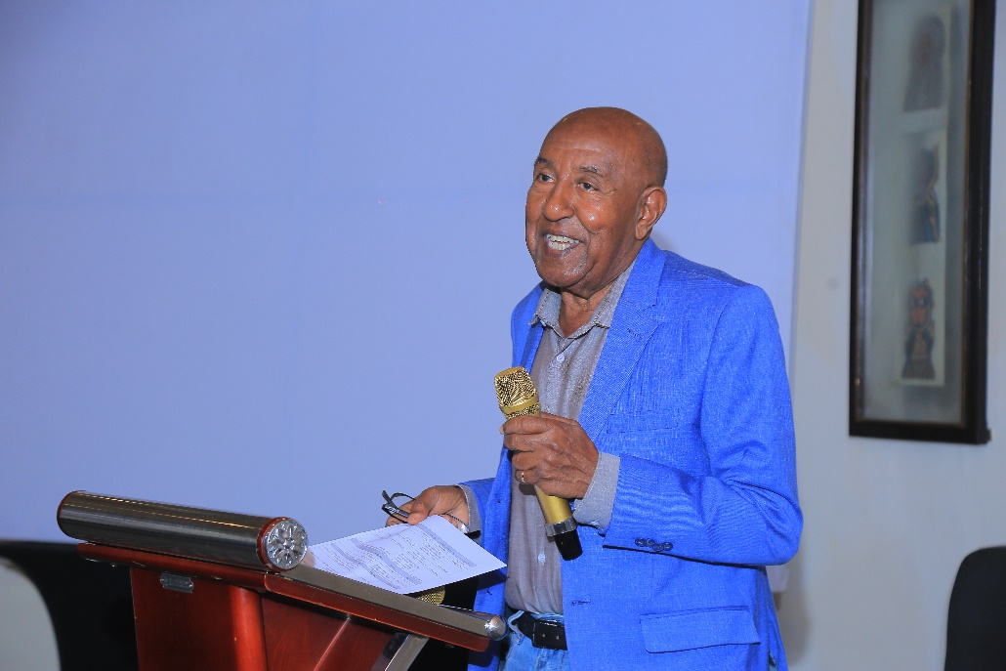
The workshop commenced with an opening remark delivered to all participants. The director expressed great pleasure in hosting everyone at the national conference and noted, in particular, the strong attendance and the encouraging presence of women among the participants. He also emphasized that their presence reflected a growing engagement with the critical and interconnected issues of the time, and it also demonstrated the relevance and urgency of the discussions to be undertaken during the event.
The director further stated that the conference formed as a part of one of the key projects of the Forum for Social Studies (FSS) focused on the interrelated themes of gender, climate change, and nutrition, which the speaker noted could not be addressed in isolation. The speaker explained that gender inequalities, environmental pressures, and nutrition challenges often reinforce one another—especially for women, children, and other vulnerable communities.
In addition, he highlighted that FSS brings a long-standing and prominent experience in conducting research and facilitating dialogue on development challenges. For more than 27 years, the institution had been actively engaged in development research and policy-relevant discussions across a wide range of thematic areas. The director also mentioned that, during this period, FSS achieved notable milestones, including the construction of its G+2 building in the Kebena area. This facility serves not only as an office space, but also as a public resource, including a library and other services intended to benefit the wider community.
The director added that FSS strengthens accessibility and knowledge sharing through its website, where research outputs and publications are made available to the public. The speaker noted that the institution’s major focus areas include gender, poverty reduction, environmental sustainability, and related issues. Through timely and evidence-based research, FSS had consistently responded to emerging development challenges and contributed insights that support informed decision-making and practical action. He cited the work of the Research Fellow, Dessalegn Rahmato, as a strong example of the depth and quality of FSS’s research contributions specifically on the issue of women land rights.
The speaker indicated that the discussions planned for the national conference were especially significant because they required the combined perspectives of multiple sectors. Many of the participants, he said, were not only attendees, but also scholars, practitioners, government representatives, climate change advocates, and youth representatives engaged in work connected to these realities. He expressed confidence that their experience and engagement would enrich the deliberations and strengthen the quality of the workshop’s outcomes.
Finally, he expressed sincere appreciation to the participants for their presence and participation, and hoped that the conference would be fruitful and constructive—providing space for meaningful dialogue, shared learning, and actionable insights to guide future actions and collaborations. With these remarks, the speaker officially declared the workshop open.

Keynote Speech: Mr. Abduljewad Mohammed Ministry of Irrigations and Lowlands; Chief Executive Officer
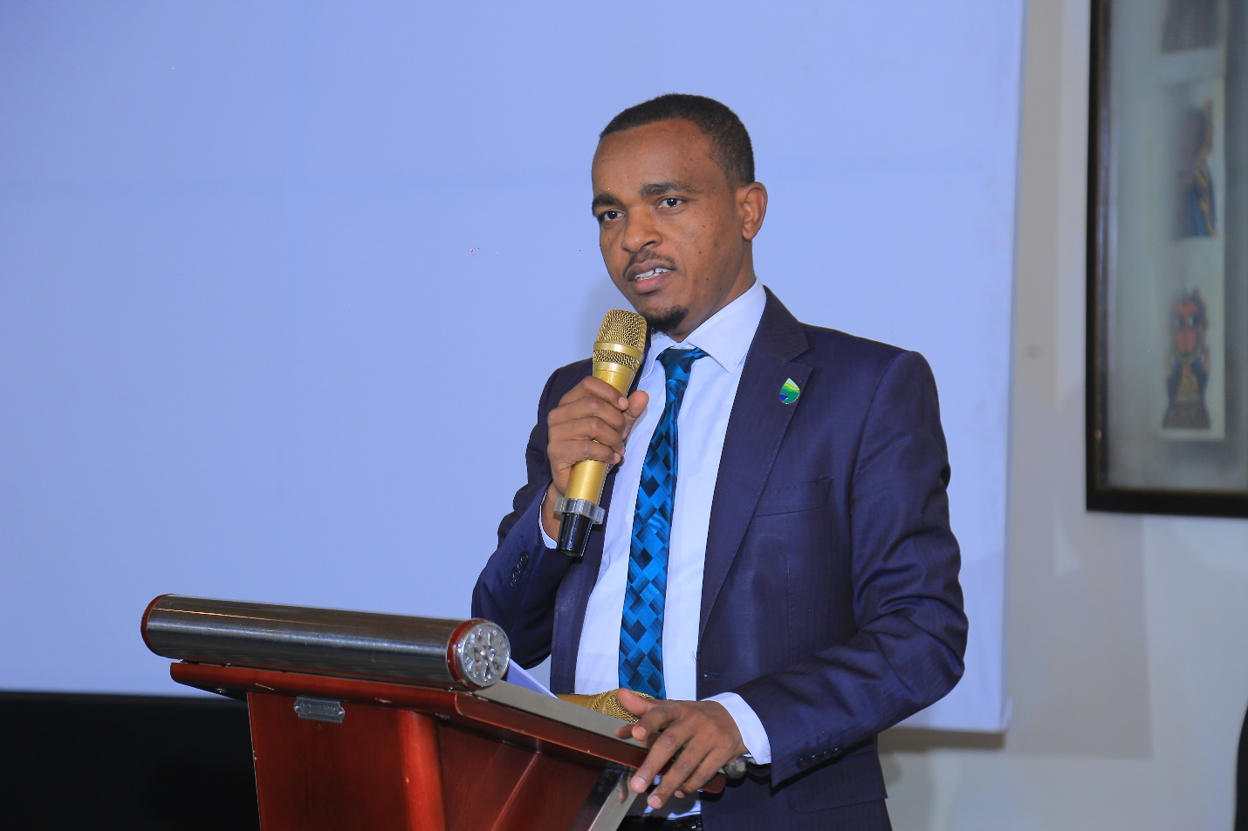

The speaker began by expressing sincere gratitude for the opportunity to participate in the conference and noted appreciation for the invitation extended to the Ministry. The speaker also commended the Forum for Social Studies (FSS) for organizing such an important platform for dialogue, describing the conference as timely and of high significance.
The speaker emphasized that the themes selected for the day gender, climate change, and nutrition are not only highly relevant but also deeply interconnected, and that they carry important implications for Ethiopia’s present and future development trajectory. From the Ministry’s perspective, the speaker highlighted the fact that climate change affects women in especially profound ways. Women especially those living in lowland and pastoral areas are among the most vulnerable groups, yet they are also key actors of resilience and transformation. For this reason, the Ministry stated that it has been implementing initiatives aimed at reducing the adverse effects of climate change with a strong focus on empowering women as both participants and beneficiaries.
The speaker further noted that historically, lowland communities were often marginalized and viewed as underdeveloped. However, he explained that Ethiopia is now working to change that narrative, stressing that lowlands are not only rich in potential but are also central to the national development agenda. The speaker stated that pastoralist communities account for about 11 percent of Ethiopia’s population and that many pastoralist communities have cross-border ties with neighboring countries, which makes climate risks and related impacts more complex and urgent.
In describing government efforts, the speaker pointed out that one important indicator of the current government’s seriousness and awareness of climate change threats is the restructuring and establishment of the Ministry of Irrigations and Lowlands. The speaker explained that in Ethiopia, around 12 percent of the community lives in lowlands and that many livelihoods in these areas depend heavily on pastoralism. The speaker also warned that climate-related natural disasters, including drought and other environmental shocks, disproportionately affect women, children, and other vulnerable groups, and can also lead to worsening food insecurity.
Mr. Abduljewad further explained that the establishment of the Ministry has enabled the government to bring more focused attention to pastoralist issues. Previously, such matters were handled under different institutions, including the Federal Affairs Bureau and later the Ministry of Peace; however, the speaker noted that the current arrangement positions Ethiopia better to respond using targeted policies and programs.
It was also stated that the Ministry’s efforts center on key areas including water access, infrastructure development, health services, and livelihood improvement, and that progress has been made in these sectors. As an example, Mr. Abduljewad referred to collaboration with the World Bank through the Lowlands Livelihood Resilience Project (LLRP), where over the past six years the project has reached more than 3 million people, half of whom are women. The speaker also highlighted that the Ministry integrates local and indigenous knowledge systems into climate resilience strategies, while also working to enhance agricultural productivity and promote food self-sufficiency. It was also noted that women remain a central focus across initiatives, with participation consistently approaching 50 percent.
At the same time, Mr. Abduljewad acknowledged several persistent challenges. He noted that structural gender inequality remains a significant concern, particularly in lowland areas, where women continue to bear a disproportionate share of the burden associated with climate change. He further emphasized that economic disparities between men and women persist, limiting women's resilience and adaptive capacity. Regarding program implementation, he explained that the Lowlands Livelihood Resilience Project (LLRP) is currently being implemented in 100 woredas and is expected to expand to 120 woredas during its second phase. However, he observed that limited financial resources, coordination challenges, and recurring environmental shocks continue to constrain effective implementation. He therefore called for more proactive, coordinated, and innovative approaches to address these challenges and strengthen the project's impact.
To strengthen evidence-based policymaking, it was indicated that the Ministry has established a research wing to identify opportunities, mobilize resources, and support informed decision-making. In this regard, the speaker expressed readiness to work closely with FSS and other partners to advance shared objectives. He also mentioned a new initiative, the Climate Resilient Systems Project (CRSP), launched in partnership with the World Bank, stating that it further reinforces Ethiopia’s commitment to climate resilience and to meaningful participation of women in development processes.
In his closing remarks, Mr. Abduljewad reaffirmed the Ministry’s commitment to supporting the Government of Ethiopia’s efforts to achieve food sovereignty and sustainable development. He expressed confidence that the conference would generate valuable insights and actionable recommendations to inform policy and programmatic interventions while strengthening collaboration among stakeholders working on these interconnected issues. He concluded by expressing his appreciation to the organizing institution for convening the conference and thanked all participants for their attention and engagement.

Presentation 1: Dr. Taddese Zerfu Overview of GCAN Project In Ethiopia
The speaker, Dr. Taddese Zerfu, Research Fellow at the International Food Policy Research Institute (IFPRI), presented an overview of the Gender, Climate Change, and Nutrition (GCAN) initiative and highlighted selected IFPRI activities in Ethiopia.
In his presentation, Dr. Taddese explained that climate change, gender inequality, and nutrition outcomes are deeply interconnected, particularly for vulnerable populations. He emphasized that climate change is not only an environmental challenge but also fundamentally a nutrition issue. As temperatures rise and extreme weather events occur, food production tends to decline, food prices increase, and malnutrition risks rise—often with women and children bearing a disproportionate share of the impacts.
He further discussed the central role women play in food systems across many contexts, including Ethiopia. According to the presentation, women are involved as primary food producers, as caregivers responsible for household nutrition, as managers of water resources, and as important decision-makers in dietary choices. However, he noted that women often face systemic constraints, including limited access to land ownership, restricted credit opportunities, and reduced ability to adopt new agricultural technologies. These barriers, Dr. Taddese stated, limit women’s capacity to adapt to changing climatic conditions and to protect household food security.
Dr. Taddese then introduced the GCAN Initiative, explaining that it was launched in 2016 to support the implementation of the U.S. Government’s Global Food Security Strategy. He noted that the initiative aims to strengthen the integration of gender, climate change, and nutrition considerations development programs and those of its partners. He highlighted GCAN’s key areas of work, including providing demand-driven technical advisory services and evidence briefs, conducting strategic research to address critical knowledge gaps, and promoting the use of open-access Feed the Future datasets through data harmonization, hackathons, and other capacity-building activities. Dr. Taddese further explained that, in 2023, additional funding from the Bill & Melinda Gates Foundation enabled GCAN to expand its operations to five priority countries.
A key element of the approach, Dr. Taddese explained, is demand-driven strategic research that examines the intersections of gender, climate change, and nutrition. He highlighted several notable synthesis products, including a 2018 review by Fanzo and colleagues on the risks climate change poses to nutrition, diets, and food systems; a 2023 review by Bryan, Ringler, and Meinzen-Dick on gender, resilience, and food systems; and a 2024 review by Bryan, Alvi, Huyer, and Ringler examining gender dimensions of climate change. These publications, he noted, provide evidence intended to inform policy and programming decisions.
To illustrate the practical relevance of GCAN research, Dr. Taddese shared one concrete example related to aflatoxin contamination. He explained that research has examined how gender and climate change may contribute to elevated aflatoxin concentrations in staple crops. The work, conducted across countries such as Niger, Burkina Faso, Guatemala, and Honduras, indicates that climate-induced water stress can increase aflatoxin levels during crop production. It also showed that poor post-harvest practices—such as inadequate drying and unsafe storage—further heighten risk. Importantly, the presentation emphasized that women are heavily involved in both cultivation and post-harvest tasks, making them key actors in efforts to reduce contamination through improved drying, storage, and consumption practices.
Finally, Dr. Taddese outlined GCAN’s ongoing and planned research directions that are relevant to Ethiopia and similar contexts. These include examining the link between women’s empowerment and climate resilience; assessing how climate interventions affect women’s empowerment; understanding women’s challenges under more stringent agricultural mitigation policies; and analyzing how climate shocks influence gendered labor allocation and food security. He also highlighted research on time-use inequalities and their impacts on diets and health, the role of digital tools in agricultural livelihoods, and the development of gendered climate adaptation metrics. In addition, he mentioned studies on drivers of retail price changes for animal-sourced foods, and on how women’s control over income affects household spending patterns. He concluded that these efforts aim to generate actionable insights for more equitable and resilient food systems.

Panel Discussion
The panel discussion was framed under the theme “Empowering Women for Sustainable Futures: Addressing Gender, Climate Change, and Nutrition.” The session was designed to stimulate meaningful debate and to deepen shared understanding among diverse stakeholders.
The panel brought together participants representing multiple perspectives and sectors:
- Mrs. Rahima Mohammed, focal person from the Ministry of Plan and Development
- Ms. Netsebrak Tamene, Young Women Christian Association (YWCA) Program Manager
- Dr. Bekele Wegi, Addis Ababa University, an academic with extensive experience conducting high-quality research on climate indicators, climate change, and gender disparities
The panel’s central aim was twofold. First, the discussion sought to create space for dialogue and debate among stakeholders, reflecting the real-world complexity of the gender–climate–nutrition nexus. Second, it aimed to broaden understanding across sectors regarding how gender considerations can be integrated into climate action and nutrition-related programming.
Above all, the panel discussion was intended to open a practical platform where practitioners could engage with the ideas presented, digest key insights, and contribute informed inputs toward the policy landscape including strengthening approaches, identifying gaps, and recommending actions that support equitable and sustainable outcomes.
The moderator, Dr. Tirsit opened the panel discussion by noting that three broad questions had been selected to guide the session. She invited the panelists to reflect on each question and also to consider their colleagues’ ideas as part of the discussion.
1) Framing the key conceptual questions: What do we mean by climate change, and how does it affect us?
Dr. Tirsit began by framing the first conceptual question: What do we mean by climate change? She asked the panelists to clarify what “climate” means and how climate change manifests in people’s lives. She emphasized that climate change should be examined through a gender lens, noting that numerous studies show significant differences in how impacts are experienced across genders.
To support the discussion, she referred to UN Women projections, stating that by 2050 approximately 158 million women could be affected by climate change compared with 16 million men, and that around 47.8 million women may face food insecurity. She then invited the panelists to identify relevant indicators that could capture these disparities.
Rahima Mohammed explained that climate change arises from both natural and human-induced causes; however, she stressed that human activities especially greenhouse gas emissions are the primary drivers. She added that Ethiopia’s Climate-Resilient Green Economy (CRGE) Strategy (developed in 2011) identifies major sources of emissions and organizes responses through two pillars: mitigation and resilience. She also noted that although climate change affects society broadly, it affects women more severely particularly in Ethiopia where gender inequality remains significant.
Rahima further stated that many women have limited awareness of climate change and restricted access to technology and early warning systems. She emphasized that droughts and floods—among the most common climate shocks in Ethiopia—intensify women’s vulnerability because women often have limited capacity to respond effectively. She called for gender-responsive policies aligned with national strategies, stressing the need for equitable resource distribution, including land ownership, agricultural inputs, production systems, and financial access along with capacity building.
Netsebrak Tamene responded by emphasizing that climate justice is a central thematic area in her organization’s work, approached through a gender equality lens. She highlighted that climate change is no longer debatable in Ethiopia, since droughts, floods, and food crises are already occurring. She stressed that women are disproportionately affected, for example, citing findings from Konso, where water sources have dried up, forcing women to travel long distances for water, often at the cost of their education. From a nutrition perspective, she explained that in Enset-growing areas, women are involved in labor-intensive production systems that become even more burdensome as climate impacts intensify.
Dr. Bekele Wegi reinforced the inseparable link between gender, climate change, and nutrition. He noted that rainfall variability and rising temperatures are increasing the frequency of climate-related shocks. While he acknowledged that climate change affects entire households, he argued that impacts are not equally distributed as women are more vulnerable due to structural inequalities, limited empowerment, and restrictive social norms. He also highlighted the need to transform the informal institutions that sustain these disparities.
Dr. Tirsit then posed a follow-up question on interventions: What specific interventions are needed for women in rural and urban areas, as well as for youth? The panelists’ reflections throughout the session emphasized both gender-sensitive resilience efforts and targeted support for nutrition outcomes.
2) Policy landscape question: Does Ethiopia’s policy framework adequately address the gender–climate–nutrition nexus?
The second broad question directed the discussion toward policy. Dr. Tirsit asked whether the current policy environment sufficiently addresses the nexus of gender, climate change, and nutrition.
Rahima Mohammed explained that climate change coordination is managed at the national level, while implementation takes place across sectors. She stated that all government institutions, together with the private sector, are involved. She also noted that Ethiopia’s environmental policy is currently under revision, and that key emission sectors such as agriculture, forestry, and transport are engaged in mitigation. Meanwhile, she described resilience-building as involving both emitting and non-emitting sectors, including Ministries responsible for Education, Health, and Women and Social Affairs. She added that climate change has been mainstreamed into the country’s 10-year development plan, requiring institutions to integrate climate considerations into their activities.
Netsebrak Tamene agreed that policies and strategies exist, but she stressed that the major challenge lies in implementation. She provided examples to illustrate ongoing efforts and innovation such as the Ministry of Transport’s initiative on electric vehicles and agricultural innovations like the use of cow dung. She also pointed to limitations in data management and disaggregation, explaining that weak disaggregated data undermines monitoring and evaluation and limits learning about what works for different groups, including women and youth.
Dr. Bekele Wegi emphasized that policy effectiveness also depends on whether interventions are sustainable and contextually appropriate. He noted that many policies may have limited impact at the individual level, particularly in lowland areas, and he argued that Ethiopia needs stronger evidence generation to guide policymaking. Without evidence demonstrating real-world benefits, he warned that policies may fail to translate into meaningful improvements in people’s lives.

3) Institutional and financial sustainability question: Can coordination and funding sustain gender-responsive climate and nutrition action?
For the third question, Dr. Tirsit focused on institutional arrangements and sustainability—especially the degree to which programs depend on external funding.
Rahima Mohammed clarified that the Ministry of Planning and Development acts as the central policymaker and coordinator, and she explained that government institutions are structured to implement climate strategies. She stated that funding is mobilized through bilateral and multilateral partnerships, and she emphasized that climate change has been mainstreamed across government institutions. She also noted that 0.5% to 1% of the national budget is allocated to climate-related activities. In addition, she said that efforts are underway—working with the Ministry of Finance—to establish gender-responsive budgeting.
Netsebrak Tamene added that much of the gender-focused work is carried out by civil society organizations (CSOs). She highlighted that sustainability depends not only on government leadership, but also on strengthening local and indigenous adaptation practices and supporting self-help groups.
Dr. Bekele Wegi acknowledged increasing government commitment, pointing to higher public expenditure on environmental issues. However, he stressed that sustainability still requires evidence-based interventions, increased investment in research and development, and greater private sector engagement to expand resources and improve delivery.
Overall, the moderator concluded that the panelists collectively highlighted the importance of:
- using gender-sensitive indicators to measure climate impacts and nutrition outcomes,
- strengthening implementation, data systems, and context-specific policy design, and
- ensuring long-term institutional and financial sustainability, including through gender-responsive budgeting and support for local adaptation mechanisms.

Reflections on the Panel discussion
During the panel session, Fiker Shiferaw from AAU and the World Bank raised important questions about whether gender issues are meaningfully integrated into planning and monitoring systems. She also emphasized concerns about the strength of political commitment and the institutional capacity needed to turn policy commitments into practical results.
Jodahi Bezabih, representing Enfluencers (The Enfluencer Network community) , further deepened the discussion by asking how communities of practice could better incorporate both gender considerations and climate change. He also inquired about the role of the private sector specifically how private actors could be engaged more effectively in climate-related actions and solutions.
In her response, Rahima Mohammed acknowledged that while many institutions have gender departments, these units often operate under significant resource constraints. She noted that efforts are underway to strengthen these departments and to move toward stronger mainstreaming of gender and climate change across all sectors. Rahima also highlighted ongoing collaboration with the Ministry of Finance to secure dedicated budgeting for gender-responsive initiatives, and she underscored active efforts to involve the private sector in climate action.
Overall, the panel reinforced the need for integrated and gender-responsive approaches to climate change and nutrition. Although Ethiopia has made progress in developing policies and demonstrating institutional commitment, the discussion made clear that major challenges persist particularly in implementation, coordination, resource allocation, and the generation of evidence. The session concluded that sustained collaboration among government, civil society, and the private sector will be critical for achieving sustainable, inclusive outcomes.

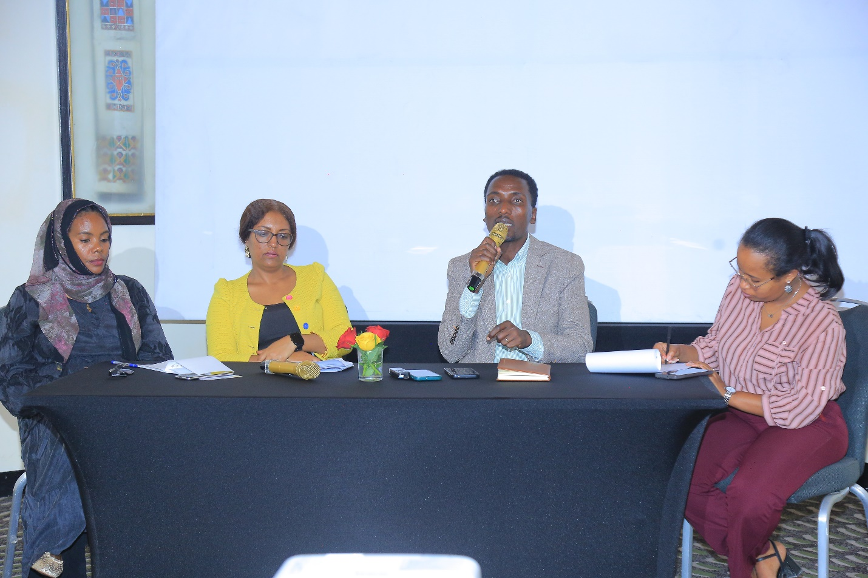

Presentation 2: Dr. Selam Esayas Capacity Need Assessment on Selected Sectors Summary of Capacity Needs Assessment Findings (GCAN–Ethiopia)
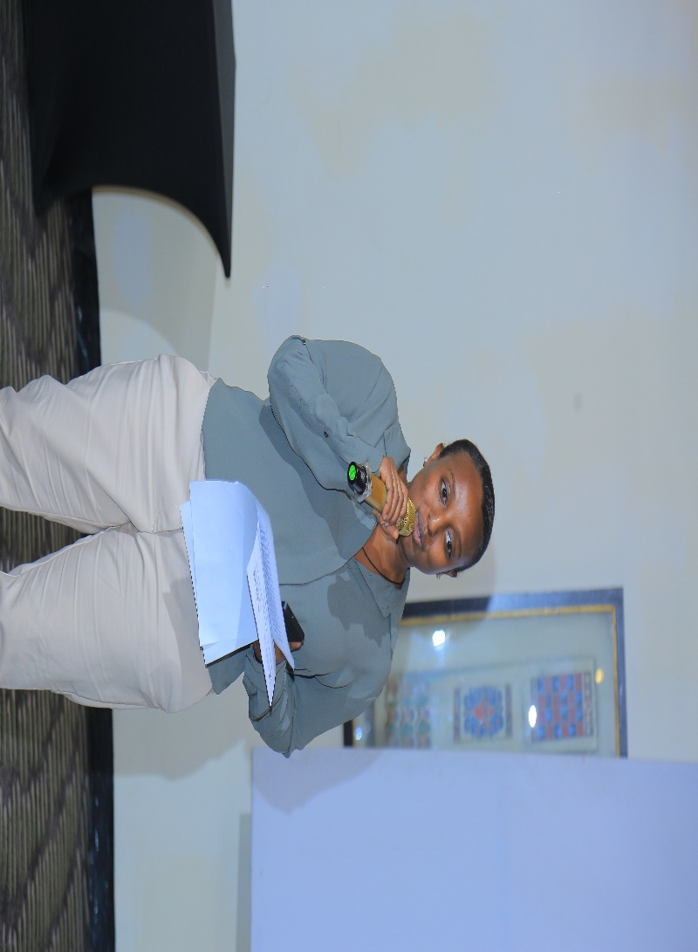
Dr. Selam Esayas, the GCAN Ethiopia Project Lead from FSS, presented the key findings of a capacity needs assessment conducted from March to May 2025 under the GCAN–Ethiopia project (2024–2027). The assessment was designed to identify stakeholders’ existing capacities, challenges, and gaps in integrating gender, climate change, and nutrition across the policy and program cycle—covering design, implementation, and monitoring.

Organizational-Level Findings
At the organizational level, Dr. Esayas highlighted several strengths. Overall, NGOs, civil society organizations (CSOs), and academic institutions demonstrated strong technical expertise and solid knowledge across the three thematic areas, particularly in gender, climate change, agriculture, and nutrition. Many organizations also reported having internal guidance systems such as policies, guidelines, and manuals along with a growing shift toward community-centered approaches that incorporate local knowledge and participatory practices.
Despite these strengths, the presentation noted persistent challenges. The assessment found that staff turnover and brain drain are limiting institutional continuity and retention of skilled professionals. In addition, integration across gender, climate change, and nutrition is often fragmented, with many organizations addressing only two themes rather than all three. Limited prioritization at leadership level, combined with barriers for NGOs/CSOs to engage effectively in national policy processes, further constrains progress. Key capacity gaps included a lack of multidisciplinary experts, declining gender expertise in some cases, absence of standardized tools for integrated programming, weak translation of research into practical action, insufficient funding, and inadequate institutional coordination.

System-Level Findings
Dr. Esayas also shared system-level findings. The assessment recognized that Ethiopia has a relatively strong enabling environment, including supportive policy frameworks, growing political commitment, and increasing stakeholder engagement. Gender mainstreaming structures such as gender desks and focal persons were also reported to exist across administrative levels.
However, the assessment identified major system-level constraints as well. These included policy incoherence, weak linkage between policy and implementation, inconsistent gender mainstreaming practices, and limited use of data and research in decision-making. Other gaps included poor access to technology, ineffective training systems, low awareness of integrated approaches, limited capacity for qualified interdisciplinary expertise especially at grassroots levels, weak intersectoral coordination, inadequate data systems, financial constraints, and insufficient incorporation of community perspectives into programming and planning.

Recommendations Presented
In conclusion, Dr. Selam Esayas outlined recommendations aimed at addressing the identified gaps. At the organizational level, the assessment suggested targeted training for different stakeholder groups, development of standardized tools and guidelines, strengthened partnerships, improved research quality, better resource mobilization, and enhanced dissemination of research findings.
At the system level, recommendations focused on improving cross-sectoral collaboration, promoting community-centered policy processes, providing technical training for decision-makers and implementers, strengthening knowledge management systems, and investing in research to generate actionable, context-specific evidence.
Overall, the presentation concluded that while Ethiopia has a strong base in policy and technical capacity, significant efforts are still required to ensure effective, integrated action across gender, climate change, and nutrition.

Participant Reflections and Discussion

First Round of Questions and Reflections
Mastewal Derara (Haramaya University)
Mastewal emphasized the need to strengthen community-centered engagement. She noted that grassroots participation is essential, yet community voices are often not adequately heard. She stressed that solutions emerging from communities should be recognized and credited. Furthermore, she advocated for a “data-to-action” approach in research and questioned the extent to which current research incorporates community perspectives.
Abera Abebe (ActionAid)
Abera raised concerns about the participation of the informal sector, noting that existing communities of practice tend to focus primarily on infrastructure. He questioned how such groups could be better integrated into broader platforms such as GCAN and how inclusivity could be improved.
Temesgen (Agri Service Ethiopia, Amhara Field Office)
Temesgen appreciated the study and highlighted the importance of recognizing traditional and local knowledge in research processes. He urged a reconsideration of how diversification and specialization are understood in development work and emphasized that research should be grounded in the actual needs of communities.
Melaku (Model African Union in Ethiopia)
Melaku raised the issue of youth participation, asking how young people are being engaged and represented within research initiatives.

Assaye Nigussie (Seed Act)
Assaye questioned the effectiveness of the prevailing top-down approach, suggesting that it may limit success. He recommended that research initiatives consider establishing dedicated task forces to ensure more coordinated and impactful implementation.
Responses by Dr. Selam Esayas
Dr. Selam Esayas thanked participants for their insightful comments and reflections. She acknowledged the importance of indigenous knowledge, noting that research efforts must better capture and highlight such knowledge systems.
She explained that there are ongoing efforts by various stakeholders to document indigenous knowledge. At the regional level, this responsibility lies with Environmental Protection Agencies, while at the federal level it is mandated to the Institute of Biodiversity. However, this division has created coordination gaps and inconsistencies in reporting structures.
Dr. Selam emphasized that research should ideally begin with the community, a view supported by their observations. However, she clarified that the current GCAN study primarily focuses on policy influence, with its methodology intentionally targeting selected stakeholders from government, NGOs, and academia. The study therefore concentrates on institutional capacity and policy frameworks, rather than direct community-level engagement.
From a theoretical standpoint, she acknowledged that a bottom-up approach is highly valuable, as it helps accurately identify community needs. Nonetheless, she noted that this particular research did not extend to that level, as it was designed to engage policymakers, program developers, and practitioners.

Second Round of Questions and Reflections
Metsehet Yinebeb (Kotebe University of Education)
Metsehet observed that many research recommendations often remain unimplemented. She stressed the need for a practical platform or tool that can translate recommendations into actionable plans for decision-makers. Such a platform, she suggested, could serve as a bridge between stakeholders and help address coordination challenges.
Dr. Taddese Zerfu (IFPRI)
Dr. Taddese introduced the concept of a Policy Innovation Hub, a recent initiative aimed at promoting action-oriented research. He explained that while ministries require evidence to inform policy and strategy development, and researchers generate such evidence, there is often disconnect between the two.
The Policy Innovation Hub was established to bridge this gap by fostering collaboration. He emphasized the importance of co-creation, where demand originates from institutions themselves, and stakeholders are actively involved in the data generation process.
He cited the collaboration between IFPRI and the Ministry of Health on the Seqota Declaration as a strong example of effective partnership and evidence-based policymaking. He also underscored that communities possess valuable knowledge and must be actively involved in climate change interventions, as success is unlikely without their participation.
Final Response by Dr. Selam Esayas
Dr. Selam agreed on the importance of establishing platforms that bridge top-down and bottom-up approaches. She highlighted several practices currently implemented by FSS to ensure that research findings are accessible and impactful:
- Organizing conferences such as this one
- Facilitating policy dialogue sessions
- Making research outputs publicly available through their website
- Producing policy briefs for each research project
She acknowledged, however, that more needs to be done. Future efforts will include capacity-building initiatives, the formation of working groups, and the establishment of task forces to enhance implementation and coordination.
Dr. Selam also announced an upcoming webinar, which will be designed to be participatory and inclusive, further strengthening engagement among stakeholders.
The discussion highlighted a strong consensus on the need to bridge policy and practice, strengthen community engagement, and promote inclusive, evidence-based approaches. While progress has been made, participants emphasized the importance of moving beyond research outputs toward actionable, coordinated, and community-driven solutions.

Afternoon sessions

Artistic performance
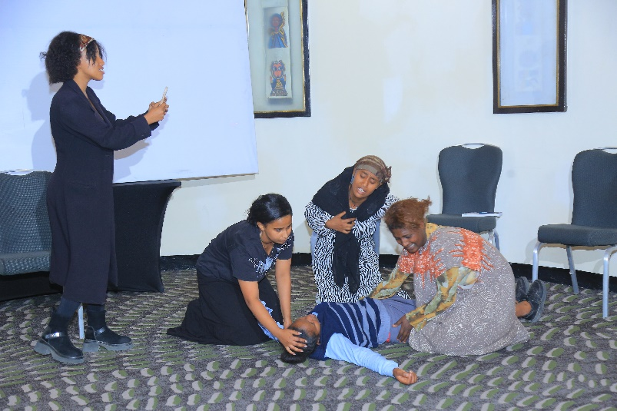
An artistic performance was delivered by youth advocates from the National Global Platform, a youth organization affiliated with ActionAid Ethiopia and the Young Women Christian Association. As part of the wider global platform, the group works to advance the inclusion of women in climate action worldwide. In Ethiopia, the platform has been using creative arts including dramas, dialogues, and other performances as an effective way to educate communities and raise public understanding.
In this session, the youth presented a short drama specifically designed to show how drought and food scarcity are affecting communities, with a particular focus on women, girls, women with children, and girls and women living with disabilities. Through realistic characters and relatable community scenarios, the performance highlighted the unequal burdens climate change createsmespecially the additional responsibilities placed on women and girls who often have to cope with hunger, inadequate resources, and limited support systems to protect their families.
The drama also addressed a critical challenge: a knowledge and understanding gap within the community about what climate change truly means and how it contributes to worsening drought and food insecurity. By dramatizing the confusion, denial, and lack of awareness many people experience, the performance called on stakeholders to take deliberate action to improve climate change awareness at community level.
Beyond raising awareness, the youth advocates emphasized the role the young generation can play in climate action particularly through social media platforms. The performance encouraged young people to use digital spaces to amplify climate-related messages, advocate for accountability, and draw attention to the realities of food insecurity caused by climate impacts.
Finally, the drama connected climate action to nutrition by underscoring the importance of protecting and supporting the natural environment not only to reduce climate vulnerability, but also to strengthen sustainable sources of healthy food for families. Overall, the performance reflected how the current generation perceives climate change and food insecurity, while also sending a clear call to stakeholders to include youth meaningfully in climate action and education efforts, so that awareness, advocacy, and sustainable solutions can reach communities more effectively.

Paper presentation 1: Dr. Kalkidan Esayas (Environmentalist and Climate Change Advocate) From Vulnerability to Leadership: Empowering Women at the Nexus of Climate Change, Gender Equality, and Nutrition Security
This presentation highlights the critical role of women in Ethiopia’s agricultural and food systems and emphasizes their potential to lead climate resilience and improve nutrition outcomes. Although women constitute about 40% of the agricultural labor force, they face significant structural barriers, including limited land ownership (12%), restricted access to credit, and inadequate climate information. These challenges contribute to a 24% gender productivity gap in agriculture and increase women’s vulnerability to climate shocks and food insecurity.
The presentation explains the interconnected nature of climate change, gender inequality, and nutrition through a systems approach. Climate shocks such as droughts, floods, and heat stress directly affect crop yields, food availability, and market access. These impacts are intensified by gender disparities in access to resources like land, finance, and training, ultimately leading to poor nutrition outcomes, including low dietary diversity and high rates of child malnutrition. In Ethiopia, only 14% of children aged 6–23 months receive a minimum acceptable diet, while 39% are stunted, demonstrating the severity of the nutrition crisis.
Climate change further exacerbates these issues. Projections indicate that temperatures in Ethiopia could rise by 1.5–2.5°C by 2050, with increased frequency of droughts and extreme weather events. Recent crises, such as the 2020–2023 Horn of Africa drought, have caused widespread livestock loss, reduced agricultural productivity, and deepened food insecurity, affecting over 20 million Ethiopians. Since 80–85% of livelihoods depend on climate-sensitive agriculture, these shocks have far-reaching consequences on income, food access, and nutrition.
Despite these challenges, the presentation argues that women’s empowerment presents a powerful opportunity to address these interconnected issues. Empowering women through improved access to land, finance, technology, and training can lead to higher agricultural productivity, better climate adaptation, improved household nutrition, and stronger community resilience. Women’s leadership in climate action and food systems is positioned as a transformative solution aligned with key Sustainable Development Goals, including Zero Hunger (SDG 2), Gender Equality (SDG 5), and Climate Action (SDG 13).
The transition from vulnerability to leadership is presented as a pathway: women move from being disproportionately affected by climate shocks and food insecurity to becoming empowered through capacity building and resource access, and ultimately to serving as innovators, community leaders, and climate champions. Policy support is essential in this process, including gender-responsive climate policies, investment in women farmers, and promotion of nutrition-sensitive agriculture.
In conclusion, the presentation underscores that empowering women farmers is one of the most underutilized yet impactful strategies for achieving climate resilience, food security, and sustainable development. When women are supported to lead, communities become more resilient, equitable, and capable of addressing the complex challenges at the intersection of climate change, gender, and nutrition.

Paper presentation 2: Fiker Shiferaw, PhD Candidate at AAU Climate-Induced Disasters and Women’s Livelihood Vulnerability in Ethiopia: A Case Study of East Badewacho District, Hadiya Zone
This presentation examines the disproportionate impact of climate-induced disasters on women’s livelihoods in Ethiopia, focusing on East Badewacho District in the Hadiya Zone. It highlights how climate change, characterized by rising global temperatures (0.16–0.18°C per decade) and increasing frequency of extreme events such as droughts, floods, and erratic rainfall, significantly affects rural, agriculture-dependent communities. Given that livelihoods in the study area rely heavily on crop farming, livestock production, and small-scale trade, climate variability directly undermines household income, food security, and overall well-being.
Using a mixed-methods research approach, the study combines quantitative surveys with qualitative tools such as focus group discussions, key informant interviews, case studies, and field observations. The findings reveal that climate-induced disasters lead to widespread crop failure, livestock loss, water and firewood scarcity, increased disease prevalence, and income reduction. These challenges contribute to the depletion of household assets, rising stress levels, and forced migration, particularly among men seeking alternative livelihoods in urban areas or abroad.
A key finding of the study is that climate change impacts are not gender-neutral. Approximately 87% of respondents indicated that women are more affected than men. This disproportionate vulnerability is rooted in existing gender inequalities. Women have limited access to climate information, often relying on indirect or delayed a source, which reduces their preparedness for climate shocks. Mobility restrictions further exacerbate their vulnerability, as caregiving responsibilities and social norms prevent timely evacuation during disasters and limit access to support services.
Additionally, women bear a “triple burden” of responsibilities—productive, reproductive, and community roles—working significantly longer hours than men. Climate stress intensifies this burden, as women must travel long distances to fetch water and firewood, leading to time poverty and limiting opportunities for education or income diversification. Cultural norms also restrict women’s access to and control over resources. While men typically control major assets like livestock, women manage smaller resources, which are often insufficient for sustaining livelihoods during crises. Food distribution practices further disadvantage women, increasing their risk of malnutrition.
The study also highlights social consequences such as increased migration of men, family separation, and rising vulnerability of female-headed households. Case evidence illustrates how women, left behind, struggle to manage households and agricultural activities with limited resources and support.
In conclusion, the presentation emphasizes that climate-induced disasters exacerbate pre-existing gender inequalities, making women more vulnerable to livelihood shocks. To address these challenges, the study recommends promoting gender-responsive climate policies, improving women’s access to productive resources such as land and livestock, strengthening climate information and early warning systems, and investing in water infrastructure to reduce women’s workload. These measures are essential for enhancing resilience, ensuring gender equity, and supporting sustainable livelihoods in climate-affected communities.

Paper presentation 3: Desalegn Amsalu, AAU Climate change-induced migration and livelihood adaptations among women migrants in Addis Ababa
This ongoing research conducted by Dr. Desalegn Amsalu and colleagues explores the complex relationship between environmental shifts and the migration patterns of women in Ethiopia. The study specifically investigates how climate change serves as a primary driver for women moving from various zones in the Amhara region to the urban center of Addis Ababa. By focusing on this demographic, the research addresses a significant gap in existing academic literature, which has historically neglected how gender mediates the migration process and how environmental impacts are experienced differently by women at the origin, during transit, and at their final destination.
At the point of origin, climate change manifests through erratic rainfall, severe droughts, and land degradation, all of which drastically reduce agricultural yields. These environmental shocks create a domino effect of livelihood loss and household poverty, forcing a shift in traditional gender roles. Women, who are deeply involved in agricultural labor such as mulching corn and weeding teff, find their burdens increased as resource scarcity makes tasks like water and fuel collection much more time-consuming. The accumulation of these pressures, combined with a lack of schooling due to conflict and rampant early marriage, eventually makes migration the most viable option for survival.
The decision to migrate is often an interaction of multiple drivers, where climate change acts in tandem with the breakdown of social networks and the loss of economic opportunities. While traditional expectations in Ethiopia often place the burden of adaptive migration on men, this study highlights an increasing trend of women seeking urban solutions to family crises. Through qualitative interviews with twenty women migrants, the research identifies that these individuals come from diverse areas, including West Gojjam, East Gojjam, Awi, Wag Himra, and various Gonder zones, all seeking to escape the "burning sun" that destroys crops before they can be harvested.
Upon arriving in Addis Ababa, these women engage in various urban livelihood adaptation strategies, though most remain within the informal sector. The study finds that migrants typically find work as manual laborers in construction, waitresses in small hotels, street vendors, or housemaids, while some are forced into begging. Even in these new roles, they face significant challenges, including wage disparity where women earn less than men for the same manual labor, and job insecurity where payments may be delayed for months, leaving them without means for basic sustenance.
The urban experience for these climate migrants is defined by a new set of vulnerabilities encompassing economic, social, and health risks. Migrants often live in poor housing conditions and face social exclusion, discrimination, and weak social networks in the city. These factors contribute to high levels of mental stress, malnutrition, and reproductive health risks, exacerbated by limited access to healthcare. Despite these hardships, many women still attempt to send remittances back home to support families whose livelihoods remain disrupted by failing crops and environmental stress.
In conclusion, the study emphasizes that climate-induced migration is a critical gendered health and social issue that requires urgent policy intervention. There is an immediate need for gender-sensitive urban migration policies and expanded healthcare access specifically tailored for women transit migrants. The researcher advocates for community-based adaptation programs that integrate climate, gender, and health perspectives, suggesting that NGOs and civil society must play a more active role in providing safe migration support and health education to protect this vulnerable population.

Questions and Discussion Session
The discussion session began with remarks from Dr. Tirsit, who expressed appreciation to all presenters for their insightful contributions. She then directed her questions to specific speakers. First, she asked Fiker Shiferaw why the analysis used 26 years of climate data, focusing on the rationale behind the chosen timeframe. Next, she asked Dr. Desalegn Amsalu why Wollo was not included in the study and whether there has been any observed shift among migrant women specifically from domestic work toward begging.
Dr. Abebe Haile (Addis Ababa University) also raised several questions to strengthen understanding of the study findings. He asked Dr. Desalegn Amsalu why drought-affected areas were excluded from the research, and to clarify which factor—conflict or climate change—has contributed more significantly in the study areas. He further asked Dr. Kalkidan Esayas how the effects of climate change can be distinguished from other drivers of child stunting. In addition, Dr. Abebe requested clarification on the difference between food security and nutrition security, emphasizing that these concepts are related but not identical.
Jodahi Bezabih asked Dr. Kalkidan Esayas to elaborate on the nutritional situation in cash crop-producing areas, particularly in the context of climate variability. He wanted to understand how climate-related changes affect nutrition even where cash crop production is present. Meanwhile, Dr. Selam (GCAN FSS) asked Fiker Shiferaw about differences and diversity among female-headed households in terms of climate change vulnerability, highlighting that vulnerability can vary across households depending on key characteristics.
In response to the questions, Dr. Kalkidan Esayas clarified the conceptual distinction between food security and nutrition security. She explained that food security focuses on consistent access to sufficient quantities of food, while nutrition security refers to access to food that provides adequate and appropriate nutrients based on age, health status, and physiological needs. she also emphasized that stunting remains a major concern in Ethiopia, particularly among children aged 6 to 23 months, who may not receive sufficient nutrition for healthy physical and cognitive development. She noted that stunting is especially prevalent in regions such as Amhara, Afar, and Somali, linking these outcomes to environmental degradation and nutrition-related impacts. Regarding cash crop areas, she explained that households engaged in cash crop production often have stronger coping and absorption capacity during climate shocks due to more diversified livelihoods.
Fiker Shiferaw responded by noting that climate datasets typically include variables such as temperature, rainfall, soil moisture, and land use/land cover. She emphasized that long-term climate records are important for identifying meaningful trends, and that research practice commonly recommends using datasets spanning 20 to 30 years. Based on these standards, she selected a 26-year timeframe for his analysis. On vulnerability among female-headed households, she highlighted that women-headed households differ substantially from men-headed households in social and economic characteristics. She explained that vulnerability varies based on factors such as landholding size, labor availability, household composition, educational status, and the age structure of household members.
Dr. Desalegn Amsalu clarified that his study did include WagHimra and that future research would expand to include North and South Wollo as well as Shewa zones. He also explained that determining whether conflict or climate change has had a stronger impact requires more rigorous quantitative analysis, as qualitative evidence alone cannot reliably separate the effects of multiple interacting drivers. Regarding migration, he described the existence of a clear shift. Historically, rural-to-urban migration involved many women engaged in domestic work, but over time begging has become increasingly common, even among able-bodied individuals. He underscored that environmental shocks remain a major driver of migration and that the frequency of these shocks has increased in recent years, giving examples such as Sekota, where recurring climate-related shocks are particularly evident.
Overall, the discussion strengthened participants’ understanding of the interconnected relationships between climate change, gender, migration, and nutrition. It reinforced the need for strong data, context-specific analysis, and integrated approaches when designing interventions to reduce vulnerability and improve nutrition outcomes.
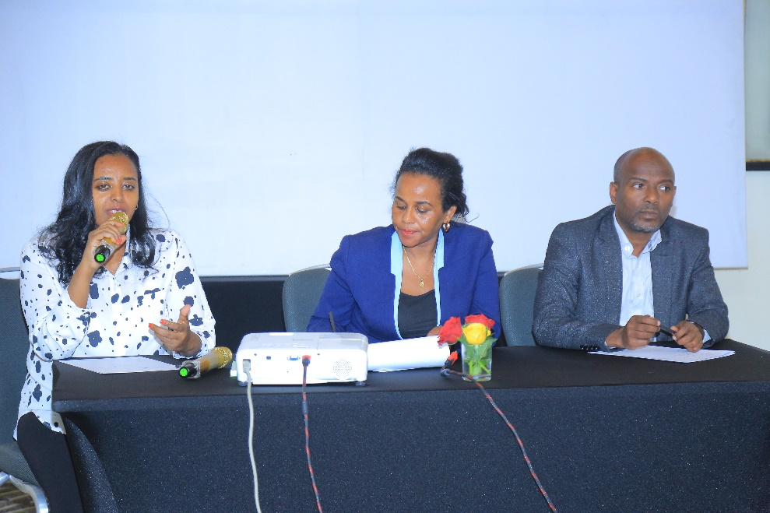

Closing Remarks by Dr. Selam Esayas
In her closing remarks, Dr. Selam Esayas, GCAN project lead at the Forum for Social Studies (FSS), expressed the hope that participants had gained valuable insights from the day’s presentations, discussions, and questions. She noted that FSS had drawn important lessons and reflections from the conference, and that these would guide the organization’s future work.
Dr. Selam also emphasized that the engagement would not end with the conference. She announced that FSS would continue the dialogue through a series of multi-stakeholder sessions, held both online and in person. She further stated that, by the end of March, GCAN would launch a set of webinar sessions to deepen dialogue, strengthen collaboration, and provide an additional platform for policy discussions and knowledge dissemination. In addition, she highlighted that an upcoming policy dialogue would be organized to open structured discussions with policy makers and practitioners.
Additionally, the capacity-building trainings, to be delivered in collaboration with We Action, will be structured into three rounds, each targeting different sectors. These sessions are designed to strengthen staff capacity, with a particular focus on integrating gender, climate change, and nutrition into their work. The trainings aim to equip participants with the knowledge and tools needed to address these interlinked challenges effectively.
She further encouraged participants to explore and engage with FSS research outputs and publications, noting that these are available on the organization’s website. Dr. Selam sincerely thanked all participants for their time, attention, and active participation, stating that their contributions had made the conference meaningful. She also invited participants to join ongoing GCAN project activities and to follow updates through various social media platforms, including X, LinkedIn, and Facebook. She concluded by reaffirming FSS’s commitment to continued collaboration, including forthcoming capacity-building trainings to be delivered in collaboration with We Action for different sectors.

Gender, Climate Change, and Nutrition Integration Initiative (GCAN) in Ethiopia
National Conference
17 March 2026 @ Hilton Hotel

Program
Time | Activities | Responsible
8:30 am - 9:15 am | Registration | FSS Team
9:15 am - 9:20 am | Welcome address | Dr. Yeraswork Admassie Executive Director, FSS
9:20 am – 9:40 am | Keynote Adress | Ato AbdulJewad Mohammed  Chief Executive Officer CEO, Ministry of Irrigation and Lowlands
9:40-10:00 am | Overview of GCAN and IFPRI activities in Ethiopia | Dr. Taddese Zerfu  (Research Fellow  International Food Policy Research Institute (IFPRI))
10am-11:20am | Panel Discussion | Dr.Bekele Wegi -AAU CSD  Rehima Mohammed -Ministry of planning and development  Netsebrak Tamene-Young Women Chrisitan Association (YWCA)
11:20– 11:40am | Tea Break | Hotel
11:40 am – 12:00 pm | Presentation on the Capacity Need Assessment Findings | Dr. Selam Esayas, GCAN project lead
12:00pm – 12: 30 pm | Reflections from audience | Dr. Selam Esayas  Project Lead
12: 30 am -1:00 pm | Artistic Performance | Youth Advocators
1:00pm-2pm | Lunch | FSS Team
2:00pm-2:20 pm | From Vulnerability to leadership: Empowering Women at the Nexus of Climate Change, Gender Equality, and Nutrition Security | Dr. Kalkidan Esayas, Environmentalist and Climate Change Advocate
2:20pm-2:40pm | Climate Induced Disasters and Women’s Livelihood Vulnerability | Fikir Shiferaw, PhD candidate, Addis Ababa University
3:00pm-3:20pm | Climate change-induced migration and Livelihood adaptations among women migrants in Addis Ababa | Dr. Desalegn Amsalu, Associate professor, Addis Ababa University
3:20pm-4:00pm | Q and A | FSS Team
4:00pm-4:15 | Closing remarks | Dr. Selam Esayas
4:15pm-4:30pm | Tea break and networking | FSS Team

